**Universal Kinect Interface**

Handbook[151009]

**P-Tracker**

* P-Tracker is the original name of this system (applications), stand for “Posture Tracker”, as it is initially developed for tracking and collecting Kinect skeleton data.
* The current system can be called “Universal Kinect Interface (UKI)”, as it’s now focusing on serving as a middleware that receive Kinect data, analyze and send input to any application.

**How UKI work?**

* **Detect** Posture/Motion & **Send** Keyboard/Mouse Event to active Window.
* “How Posture/Motion is detected”, “Which Event to be sent”, “Which Motion map to which Event”  
  are stated on MAP file (XML).

**UKI Quick Start**

Requirement: MicrosoftFramework & KinectSDK

1. Run P_Tracker2.exe, then click “Universal Interface”  
   The App will automatically resize to full screen with optimal setting for UKI.  
   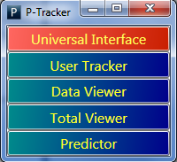
2. Check “XML” radio checkbox and select XML on combo box.  
   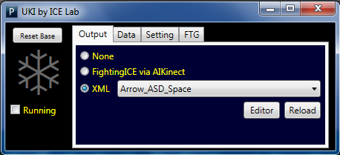
3. Make sure the App (that get inputs) is on top ; make it look like this  
   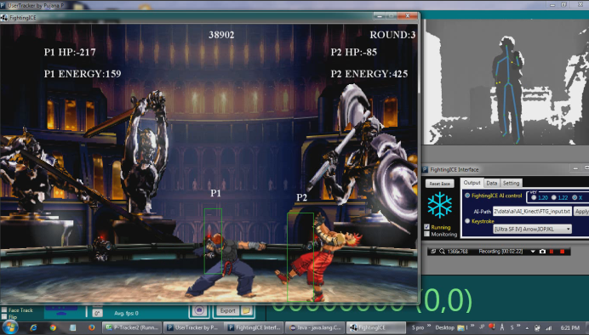
4. Now, the “ICE” icon should be grey, which indicate that “Base Posture” is not recognized yet.  
   Stand Up Straight and do Jiangshi posture; icon will turn to red (Base Posture Recognition).  
   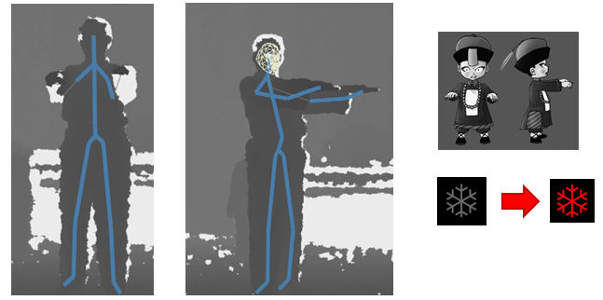
   1. Posture Detection is done by comparing Posture at a specific time with Base Posture  
      So Base Posture MUST be properly recognized   
      (watch skeleton and ensure that noise is on acceptable level when icon turn to red)
   2. If Base Posture is not properly recognized, press “Reset Base” Button
5. “ICE” icon is red = interface is off.  
   To turn on by doing one of these postures (2 hands are closed at the chest level).  
   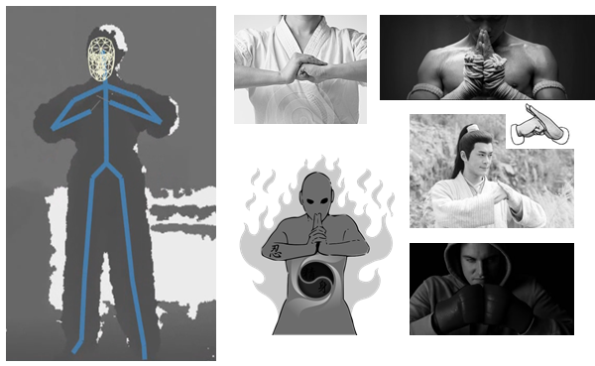
   1. Blue Icon = the interface is turned on and ready-to-use.  
      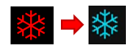
   2. To turn off, do the same posture, but hands must be at or above the head level instead.

**Understanding MAP file**

1. Sample MAP files are provided, let’s try and learn by real experience
   1. Arrow_XCZ_Space :  
      <http://www.playgames3d.com/kung-fu-master.html><http://www.playgames3d.com/3d-kickboxing.html> The following are detail which postures is mapped to which character action
      1. Step Forward & Backward (Right Foot) Walk Forward & Walk Backward
      2. Lean Forward & Backward Fast Move Forward & Backward
      3. Jump & Crouch Jump & Crouch
      4. Right Punch & Left Punch & Guard X & C & Z
      5. Raise Left Hand Switch Size
   2. Arrow_ASD_Space : <http://www.online3dgames.net/games/296/play-kung-fu-panda-2-kung-fu-rumble>   
      Similar, but attack & guard button are A&S&D instead of X&C&Z
   3. Sample VDO: <https://www.youtube.com/playlist?list=PLwrbb0kRyPsmhLmi8FN_Dl1KoynMoRE2r>
2. Click Editor to see MAP file detail  
   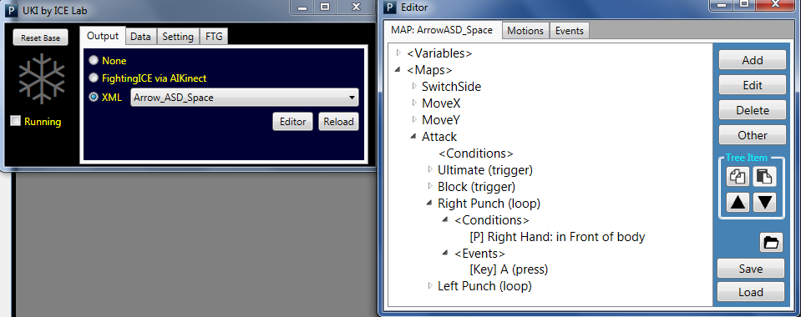
   1. First Tab, “MAP: xxx” is selected MAP file
   2. “Motion” Tab is Motion database (Condition), there is only 1 database.  
      Motion in this database can be called/reused by clicking Add on MAP file.
   3. “Event” Tab is Event database.

** Sample of calling Motion from the database **  
 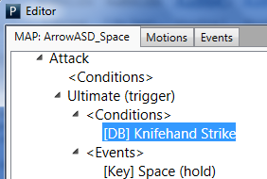 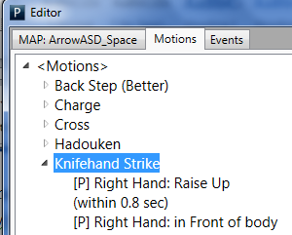

**Collecting UKI Tracking Data**

1. On Data Tab, check Collect Data  
   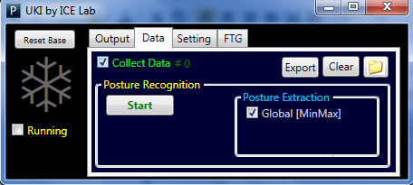
2. Click Export to export data, click folder button to go to the directory, open file by excel.  
   For beginner, try looking at “r2_xxx”, which is relative range on a single axis between 2 joints.   
   For example, “r2_hL_sC_Z” = LeftHand.Z – ShoulderCenter.Z

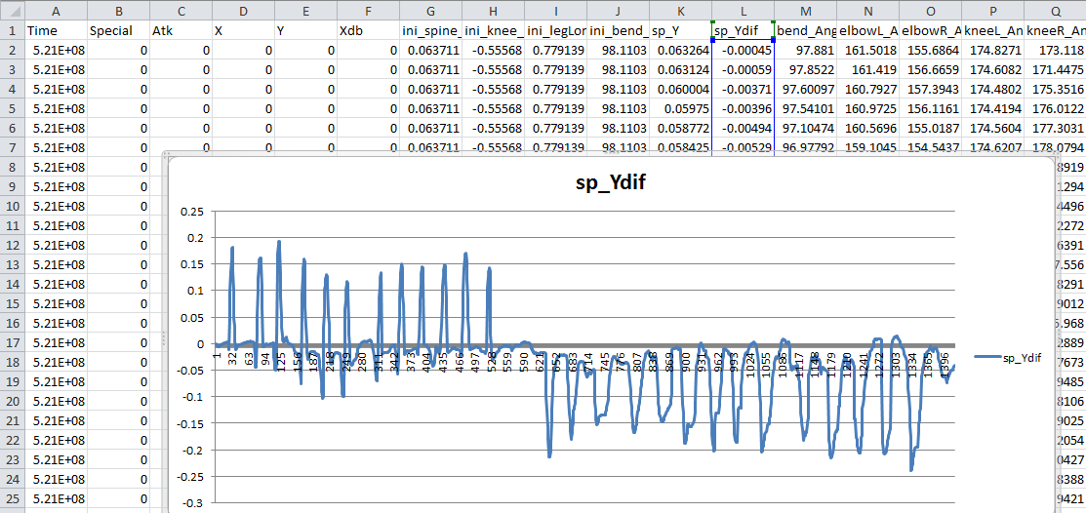

E.g. Sample of usage, finding threshold for jump & crouch detection

**Posture Recognition [Incomplete, Prototype]**

1. Click Start  
   
2. After Base Posture is recognized, wait until counter count down to 0.
3. Perform Motion
4. After finish performing motion, be still until counter count down to 0.
5. System will generate rules, and write log file, open Folder button to go to the file.

**Other Info**

Hand book is included,   
OWS = Office Workers Syndrome Monitoring System  
UKI = Universal Kinect Interface  
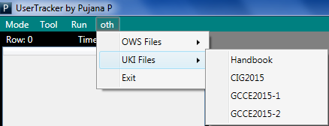

************** END OF UKI PART ***************

** The following are manual for other usage **

**Basic Start**

1. Click User Tracker  
   
2. Click Start to connect Kinect  
   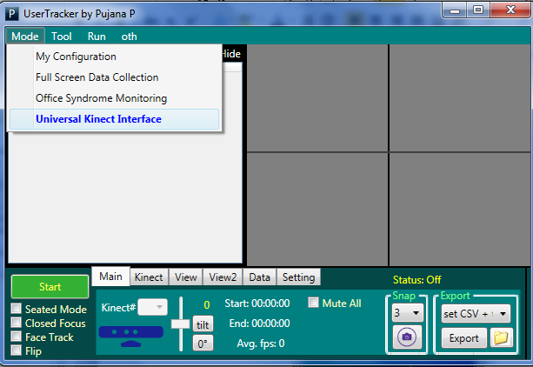
   1. If you click at “Move” >> “Universal Kinect Interface”, you will get the same result as click “Universal Interface” in the index page.

**Data Collection : Basic Kinect Data [after Basic Start]**

1. If Start Button is clicked (Button.Text = “Stop”), the system is running and it will continuously collect data until Stop is press.  
   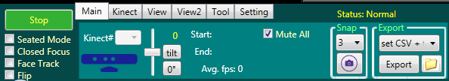
   1. Uncheck “Hide”, to see table of streaming data
2. When “Stop” is clicked, it will ask whether to save data or not.
   1. In case, it has run for a short period, it might not ask.  
      You can save manually by clicking Export
3. Click Folder icon to open file location
4. Sample of saved file, you can open it by excel for plotting graph,   
   or import it into SAS, SPSS, Weka, etc. for Data Analysis  
   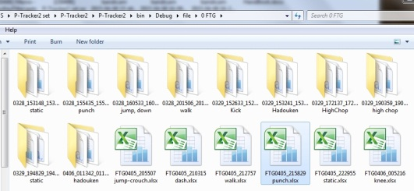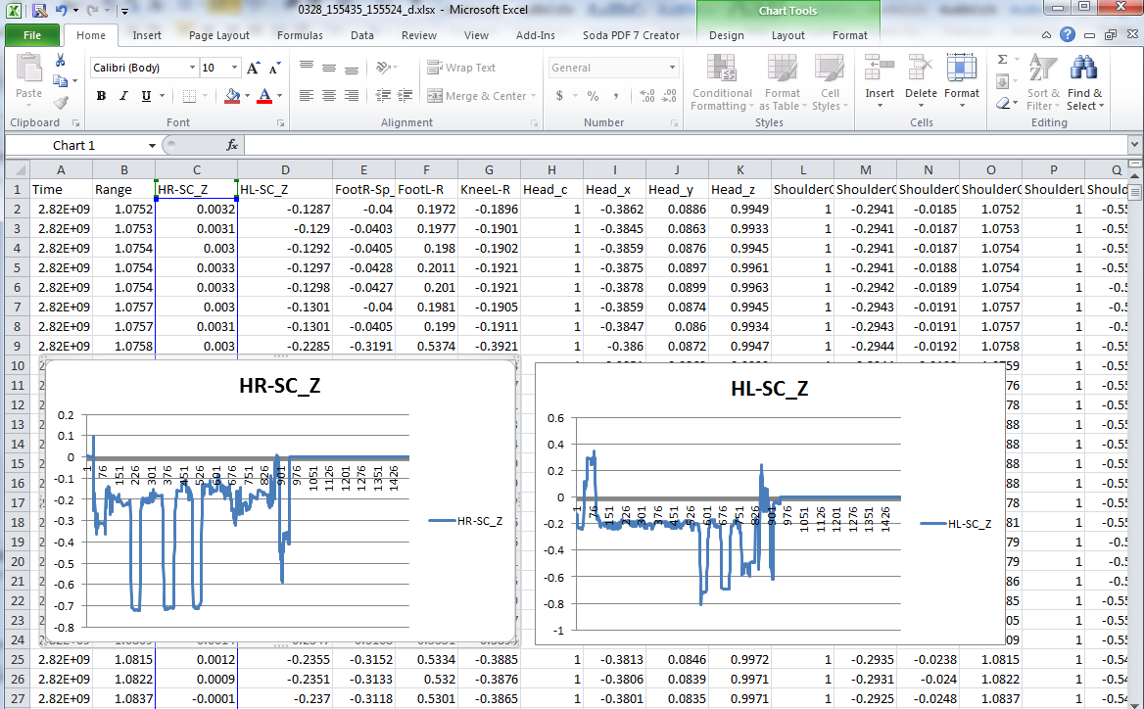

**Another way to control FightingICE character (Obsolete Method)**

1. Put “AI_Kinect.jar” into AI folder  
   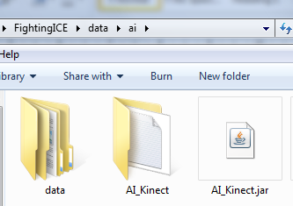
2. Create “AI_Kinect” folder (you may also create blank file name “FTG_input.txt” )  
   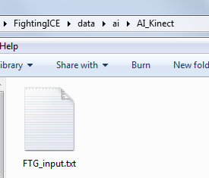
3. In UKI, check radio button as the following  
   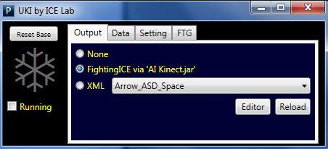
4. Set AI-Path  
   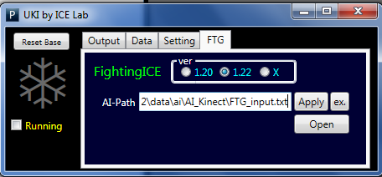
5. More Info
   1. “AI_Kinect.jar” works by “EasyKey Filter”, which mean you control this AI by setting   
      5 simple parameter. AI will handle detailed steps for you  
      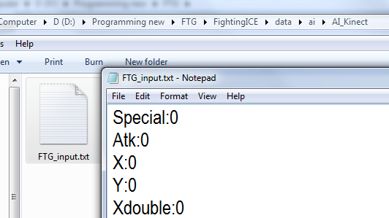
   2. In this method, UKI send command to AI via “AI_Kinect /FTG_input.txt”

**STREET FIGHTER Ultra IV Button Setting : for sample “[SF4] Arrow_IOPJKL.xml”**

